Supplementary information
LncRNA SLC1A5-AS/MZF1/ASCT2 Axis Contributes to Malignant Progression of Hepatocellular Carcinoma
Supplementary Figures and Figure Legends
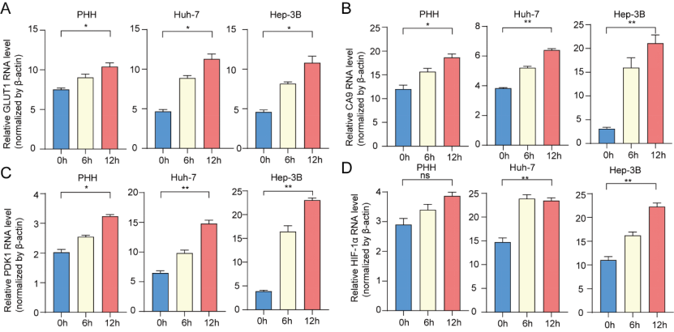
Supplementary Fig. 1. Validation of the efficiency of hypoxia model construction.
(A-D): Relative mRNA level for (A) GLUT1; (B) CA9; (C) PDK1; and(D) HIF-1α in PHH, Huh-7, or Hep-3B cell lines after 0,6 and 12 hours of cobalt chloride treatment. Examined by qPCR and normalized by β-Actin. Values are expressed as the mean ± SEM, n = 3. 0.001 < **P< 0.01< *P < 0.05 < ns.

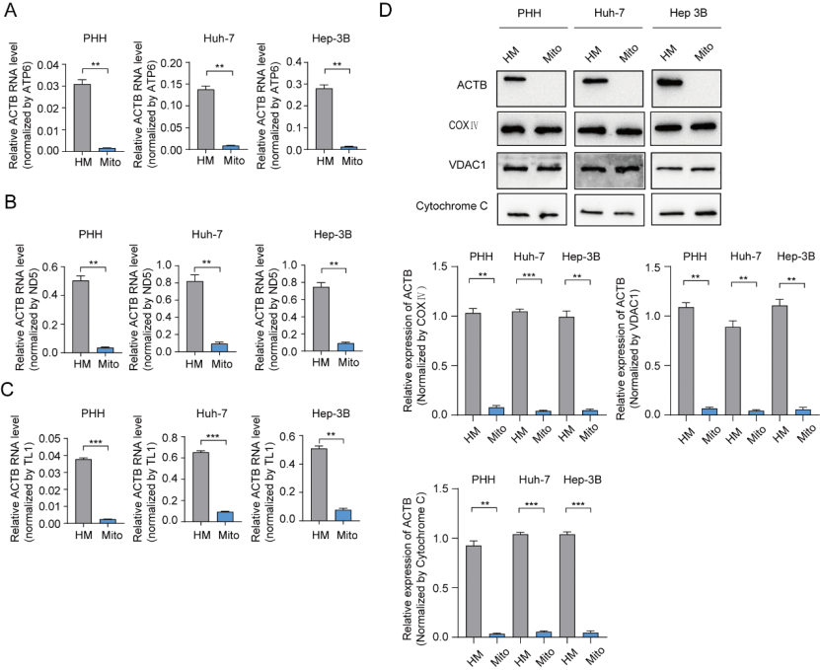
Supplementary Fig. 2. Validation of the efficiency of mitochondrial isolation.
(A-C): Relative mRNA level for ACTB (cytoplasm) in PHH, Huh-7 or Hep-3B cell lines. Examined by qPCR and normalized by three mitochondrial DNA ((A) ATP6; (B) MT-ND5; or (C) MT-TL1). Values are expressed as the mean ± SEM, n = 3; (D): The protein levels of ACTB and three mitochondria-associated proteins (COX Ⅳ, VDAC1 and Cytochrome C) in PHH, Huh-7 or Hep-3B cells were determined by immunoblotting. “HM” represents the homogenate component and “Mito” represents the mitochondrial component. Corresponding gray value measurement and data statistics were employed. ***P < 0.001 and **P < 0.01.
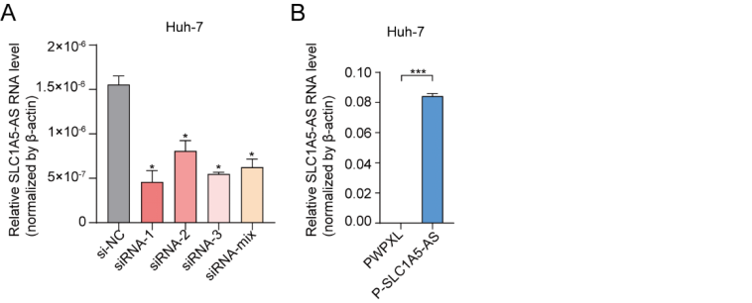
Supplementary Fig. 3. Validation of SLC1A5-AS knockdown and stable overexpression efficiency.
(A) Validation of SLC1A5-AS RNA level expression in Huh-7 cell lines by qPCR following independent knockdown of SLC1A5-AS in four groups. (B) Stable overexpression of SLC1A5-AS followed by qPCR to verify the RNA level expression of SLC1A5-AS in Huh-7 cell lines. The results were normalized by β-Actin and values are expressed as the mean ± SEM, n = 3. ***P < 0.001, 0.01 < * P <0.05.
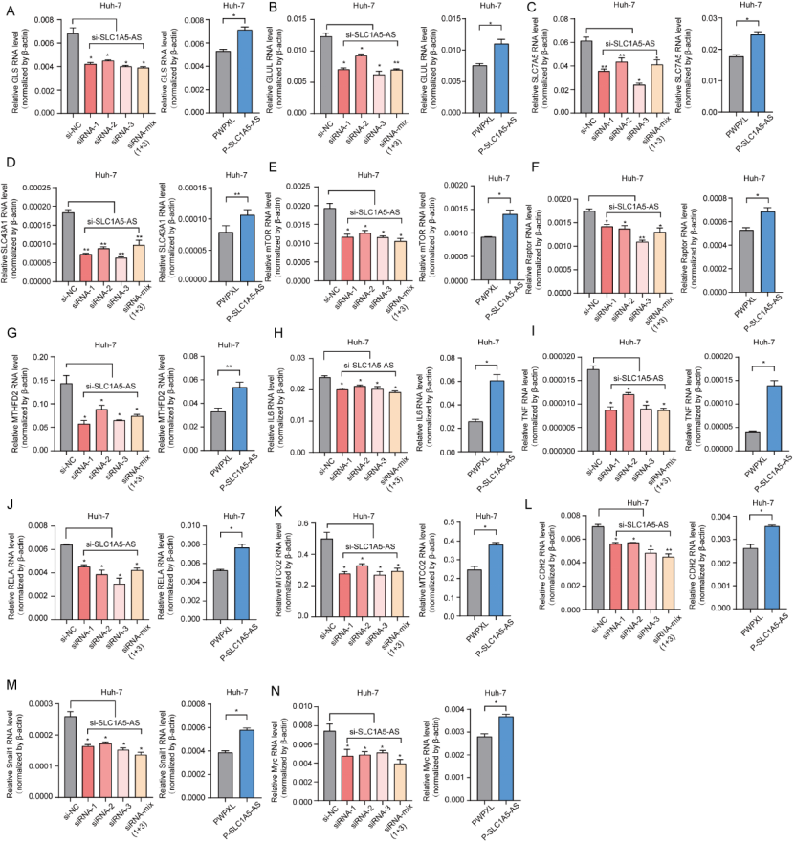
Supplementary Fig. 4. Validation of top-regulated genes in signaling pathways that SLC1A5-AS involved.
(A-N): Relative mRNA level for top-regulated genes in (A-B) glutamine metabolism (GLS, GLUL); (C-D) L-amino acid transmembrane transporter activity (SLC7A5, SLC43A1); (E-G) mTORC1 signaling pathway (mTOR, RAPTOR, MTHFD2); (H-I) TNF signaling pathway (IL-6, TNF); (J-K) NF-κB signaling pathway (RELA, MTCO2); (L-M) EMT signaling pathway (CDH2, SNAIL1) and (N) ErbB signaling pathway (Myc) in Huh-7 cells. Examined by qPCR and normalized by β-actin. Values are expressed as the mean ± SEM, n = 3. 0.001 < **P < 0.01 < *P < 0.05.

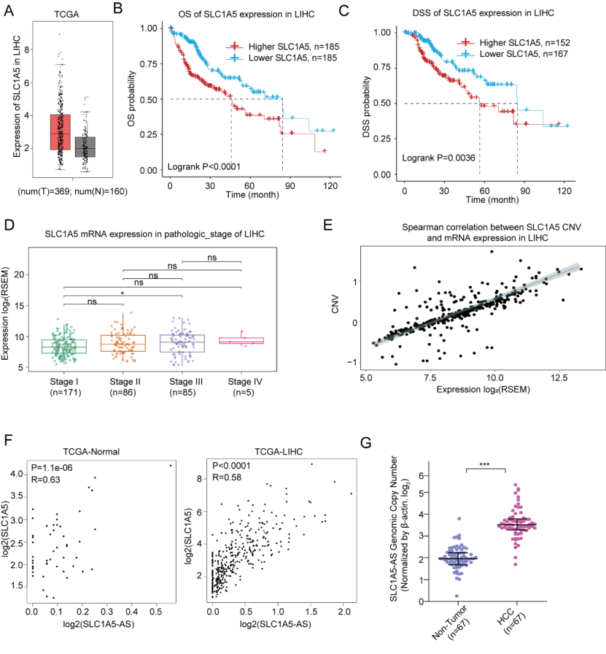
Supplementary Fig. 5: SLC1A5-AS has a strong positive correlation with the SLC1A5 gene in HCC tissue.
(A): mRNA level of SLC1A5 in HCC(n = 369) and NT tissues(n = 160) from TCGA-LIHC (Cohort 2); (B, C): Overall survival rate (P<0.0001) (B) and disease Free Survival rate (P=0.0036) (C) of patients with high (n = 185 and n = 152) or low (n = 185 and n = 167) SLC1A5 mRNA level; (D): mRNA level of SLC1A5 in Stage Ⅰ (n = 171), Stage Ⅱ (n =86), Stage Ⅲ (n =85) and Stage Ⅳ (n =5) of LIHC; (E): Spearman correlation between SLC1A5 copy number variation and mRNA expression in LIHC; (F): Correlation between SLC1A5-AS and SLC1A5 in normal or HCC tissues; (G): Genomic copy number of SLC1A5-AS (β-actin as control) in non-tumor (n =67) or HCC tissues (n =67). ***P < 0.001, 0.01 < *P < 0.05 < ns.

Supplementary Fig. 6: Prediction of Transcription Factors Associated with SLC1A5 and Their Correlation with SLC1A5.
(A): The TFs list of SLC1A5 predicted by JASPAR; (B): Correlation between SLC1A5 and TFs in HCC tissues.
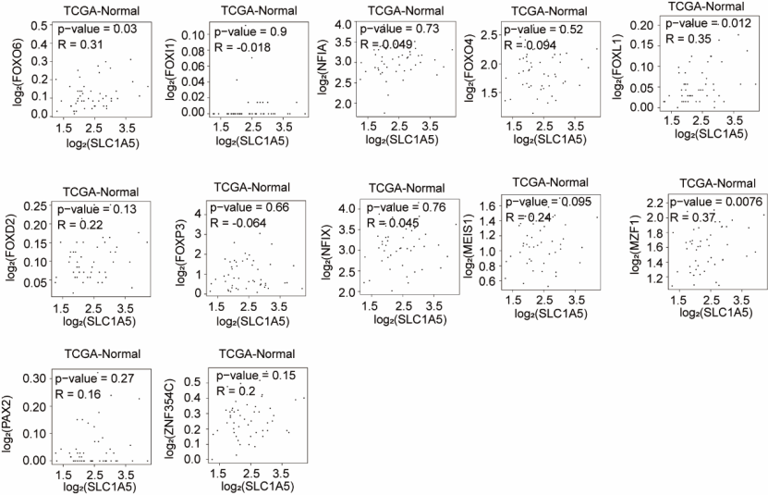
Supplementary Fig. 7: Correlation between SLC1A5 and TFs in normal tissues.

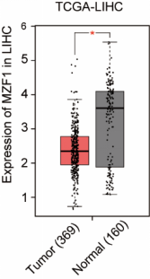

Supplementary Fig. 8: Expression of MZF1 in HCC and NT tissues.
mRNA level of MZF1 in HCC (n = 369) and NT tissues(n = 160) from TCGA-LIHC (Cohort 2). 0.01 < *P <0.05.

Supplementary Table 1. Multivariate Cox regression analyses of SLC1A5-AS in liver cancer with clinicopathologic factors
Characteristics | HR | 95% CL | P -value
Gender (Female vs Male) | 0.981 | 0.380-2.355 | 0.96
Age (＜60 vs ≥ 60) | 0.763 | 0.217-1.897 | 0.46
Tumor size (cm) (<5 vs ≥5) | 3.637 | 1.687-7.4133 | 0.001
Differentiation grade (Well and moderately vs Poorly) | 3.628 | 1.630-6.836 | 0.001
Tumor stage (I-II vs III-IV) | 5.139 | 1.901-13.196 | 0.001

Supplementary Table 2. Sequences for the primers and siRNA.
Primer name | Forward primer (5'→3') | Reverse primer (5'→3')
SLC1A5-AS-qpcr | GTTCGGAGACTGGACGAGTAG | CACCGGAGCTTTCTAGCGAC
RP11-37C7.1-qpcr | AGACCCGAAACAGCAAGAA | AGCACCTCCAAAGAAGCATT
RP11-395I14.2-qpcr | CCAGCCTACATCCTTCTCC | TTGCTTTGTCCAGCCATC
CTB-12A17.3-qpcr | GCCTACCTGCCCTTACCCT | CTCTTTCTCCTTCTTCCCTGA
CTD-2616J11.10-qpcr | TGCCTGCTTAGGGAGTGG | GTGGCACGATCTCGGTTC
CTD-2515A14.1-qpcr | GGCATGTGCTGTCTGTGG | GCTTGAATCTAGGAGGTGGA
RP11-53I6.4-qpcr | CATTCTGAGGATCAAGCATCACT | TTAAGTTCAACTTTTTAAACTCTGGC
RP11-290L1.3-qpcr | CAGGCAGAGTTGGAGGTG | CTGTGGTGATGGCAGAGG
AC091185.1-qpcr | CTGGCTTTCCTTGCTCCT | AAATTCCCTTGCTTTGTCC
AL109936.6-qpcr | CAGGCACAGTGGCTCACA | GGGTTCACGCCATTCTCC
AL645608.8-qpcr | AAGGAAGTCCCCACGCTGACC | CCCCATCCCTCTACTGAGTGTCT
AC005363.2-qpcr | TTTCGGCGTTCTGGGATG | GATTACCCGGTTTATTCATTTACCT
AC025171.4-qpcr | AAACTTGGTGTTGGCATTA | ATTCCCACGTTCCATTCA
AC080038.2-qpcr | GAGCCACAGCCACCAGAA | GGAAAGGGTCCCATTAGCC
AL049794.2-qpcr | GCTTAATTGCATTCCTGGGACA | GCCTGCTGCCATCAAACC
SNHG19-qpcr | ACCACTTTGTCCCTTAGCGT | CACTTCAATAGACACAGCGCC
MIR222HG -qpcr | TGGTTGTGACCGACTTGA | CCCTCTTCGCAGCTTGAT
AC009271.1-qpcr | AAATGAAAGAAGCTGGTTG | TACTGCTGGTGGGAATGT
AL355353.1-qpcr | AAAAGGCGGACAGAAGGAGG | CCCGACGAAGACCAAATGC
AC012442.1-qpcr | AATGGGATCAAGTGAGCAGC | CCCTTTCAGGGACAGGAAC
LINC01271-qpcr | GCATCTTCTCCGCCTGAGTC | TGTGTGGTGCTAACTTGCCT
AC020891.2-qpcr | TGGGCTGCTCATCAAGGA | TGAGTGAGGGACATAAGTGGG
AC011450.1-qpcr | GGAGTTCTACAGCCACAAGC | AGGAGACCTGGGAAATGAA
AC003070.2-qpcr | GCCAGGGAGGAGACCAGCTT | AGCGTGCCGGGGTTACAGG
LINC02444-qpcr | CTGGGCAAGAAGCACAAGAG | AGCATTGAGTGGATCCGGC
AF038458.2-qpcr | GCCTCGGCTTCCCAAAGA | ATGGCTTAAACCTTCAACTGTCTTCT
AC007619.1-qpcr | TGAAACCCTCAGCAACCT | TGTAATCCCAGCTACTCG
AC009262.1-qpcr | CTTCTGCCAATGCGACTC | TGCAGTTTCTCTAGCAAT
AC022167.3-qpcr | GAGTCCGCCTCCCAACCTG | TGTCATTCCCAGCCTGTATCCCA
SLC1A5-qpcr | CTCGATTCGTTCCTGGATCTT | GTTCCGGTGATATTCCTCTCTTC
HIF-1α-qpcr | ACAGTACAGGATGCTTGCCA | GGGCCAGCAAAGTTAAAGCA
GLUT1-qpcr | ATCCTCATCGCCCAGGTGTT | CGCATCATCTGCCGACTCTC
PDK1-qpcr | ACACCCAAACGTCGATATTCCT | AAGGCTGCCATGTTGGAGAT
CA9-qpcr | AATGGGCGAGTGATTGAGGC | GTAGCTCACACCCCCTTTGG
MTTL1-qpcr | CCTAGGCGACCCAGACAA | GGGACGGATCGGAGAATT
ND5-qpcr | ACTGTTCATCGGCTGAGAGG | AGTAGGGCTGAGACTGGGGT
ATP6-qpcr | ATCCCCACCTCCAAATATCT | AATCACTGTGCCCGCTCATA
GLS-qPCR | ACAGGGTCTGTTACCTAGCTT | TGGGATCAGACGTTCGCAAT
GLUL-qPCR | TGGACATGGTGAGCAACCAG | TACAAGCAGGCCCGGTAATG
SLC7A5-qPCR | GTGAACTGCTACAGCGTGAAGG | AATGTTCCCCACATCCAGTTTG
SLC43A1-qPCR | TCCCTGAATGGCTTTGGTGG | CGTAATGGCAGAAGAGGCGT
RAPTOR-qPCR | CTGAATGTTGGTGTGGACCCT | TGCACCGATGGTTTCCAGAG
MTHFD2-qpcr | CCTTGTTCAGTTGCCTCTTCCA | CTTCCAGCCACAACCACATTC
mTOR-qpcr | AATGCCACCCGAATTGGCAG | AGAAGAAGGTAGGGACGCTG
IL6-qpcr | GGCAGAAAACAACCTGAACCTT | CTGGCTTGTTCCTCACTACTCT
TNF-qpcr | CTCGAACCCCGAGTGACAAG | TATCTCTCAGCTCCACGCCA
RELA-qpcr | CTTCCAAGAAGAGCAGCGTG | GAGTTTCGGTTCACTCGGCA
MT-CO2-qpcr | GGCACATGCAGCGCAAGTAG | TGATGGCGGGCAGGATAGTT
MYC-qpcr | AGGACCCGCTTCTCTGAAAGG | CACCGAGTCGTAGTCGAGGT
CDH2-qpcr | AGACTGGGTCATCCCTCCAA | ATGAAACCGGGCTATCTGCT
SNAIL1-qpcr | CTCAAGATGCACATCCGAAGC | CATCTGAGTGGGTCTGGAGGT
pWPXL-CTB-147N14.6 | GGGATCCAGGCCTAAGCTTACTCGAAGGCAGCGGCGCACC(MluI) | TTGTAATCCAGAGGTTGATTATCATTTTAACACCTGCACTTTATATTCGAGGAATTAAAG(NdeI)
SLC1A5-AS-Pulldown  -Sense | TAATACGACTCACTATAGGGAGACTCGAAGGCAGCGGCGCACC | TTTTAACACCTGCACTTTATATTCGAGGAATTAAAG
SLC1A5-AS-Pulldown  -AntiSense | CTCGAAGGCAGCGGCGCACC | TAATACGACTCACTATAGGGAGATTTTAACACCTGCACTTTATATTCGAGGAATTAAAG
β-actin-qpcr | TTGGCCAGGGGTGCTAAG | AGCCAAAAGGGTCATCATCTC
U2-qPCR | TGTTCCTGCATCTCCACATC | ACGTTTAGCCAGACCATTGC
GAPDH-qpcr | GTCTCCTCTGACTTCAACAGCG | ACCACCCTGTTGCTGTAGCCAA
SLC1A5-AS-5’RACE | TCTGGCACACGGGGCAGAGCAGAGAAGC
SLC1A5-AS-3’RACE | GCTGAGGCTTCTCTGCTCTGCCCCGTGT
SLC1A5-AS-Northern probe | TAATACGACTCACTATAGGGAGACTCGAAGGCAGCGGCGCACCTGGTC | CCGCCAACGGGGGCCTGGCGCTGGCCTC
si-CTB-147N14.6-1 | CTCGGTGATTCATTTGCAA
si-CTB-147N14.6-2 | CCCATAGAAGGCAGATTAA
si-CTB-147N14.6-3 | GGTCTTTAGTCGCCTCTGA
si-ASCT2-1 | GCTTGGTAGTGTTTGCCATCG
si-ASCT2-2 | GCTTATCCGCTTCTTCAACTC
si-ASCT2-3 | GCCTTGGCAAGTACATTCTGT
si-NC | AGUACAGCAAACGAUACGGTT

Supplementary Table 3. Antibodies for western blot and ChIP.
Protein Name | Company | Catalog Number | Dilutions in WB
SLC1A5 | Proteintech | 20350-1-AP |  | 1:1500
COXIV | Proteintech | 11242-1-AP |  | 1:1500
VDAC1 | Proteintech | 55259-1-AP |  | 1:2000
Cytochrome c | Proteintech | 66264-1-Ig |  | 1:2000
MZF1 | Santa Cruz | sc-293218 |  | 1:2000
Normal rabbit IgG | Sigma-Aldrich | NI01 |  | /
GAPDH | Proteintech | 60004-1-IG |  | 1:2000
β-actin | Proteintech | 60008-1-IG |  | 1:2000
Goat Anti-Mouse IgG(H+L) | Proteintech | SA00001-1 |  | 1:2000
Goat Anti-Rabbit IgG(H+L) | Proteintech | SA00001-2 |  | 1:2000

